**Techno India NJR Institute of Technology**



**Course File**

**Session 2020-21**

**MT (5ME4-03)**

Abhishek Sharma

(Assistant Professor)

**Department of ME**

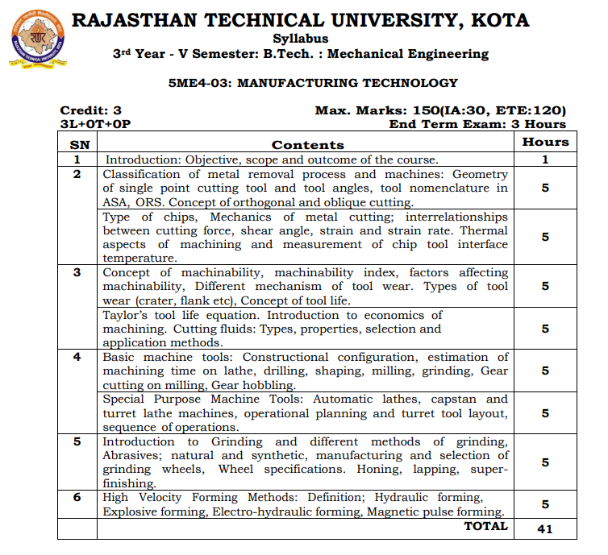

**Course Overview:**

Theory of Machines deals with **the study of relative motion between the various parts of machine, and forces which act on them**. ... It combines theory, graphical and analytical skills to understand the Engineering Design. This subject contains marks weight-age of 8 to 9 in GATE Mechanical Engineering.

**Course Outcomes:**

|  |  |  |
| --- | --- | --- |
| **CO. NO.** | **Cognitive Level** | **Course Outcome** |
| 1 | Knowledge | Understand the cutting tool geometry, mechanism of chip formation   and mechanics of orthogonal cutting |
| 2 | Knowledge | To gain knowledge of grinding and different methods of grinding. |
| 3 | Knowledge | To learn about the concept of tool life etc. |

**Prerequisites:**

1. Basic Knowledge about Free Body Diagram
2. Must have completed the course on Manufacturing Process and Basic Mechanical Engineering.

**Course Outcome Mapping with Program Outcome:**

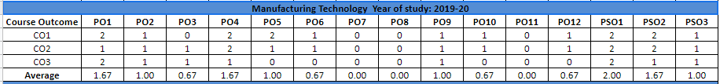

**Course Coverage Module Wise:**

|  |  |  |
| --- | --- | --- |
| **Lecture  No.** | **Chapter** | **Topic** |
| 1 | **1** | **INTRODUCTION:** Objective, scope and outcome of the course. |
| 2 | **2** | **CLASSIFICATION OF METAL REMOVAL PROCESS AND  MACHINES** |
| 3 | 2 | Geometry of single point cutting tool and tool angles |
| 4 | 2 | Tool nomenclature in ASA |
| 5 | 2 | Tool nomenclature in ORS |
| 6 | 2 | Concept of orthogonal and oblique cutting. |
| 7 | 2 | Type of chips |
| 8 | 2 | Continues chip with buildup edge |
| 9 | 2 | Mechanics of metal cutting |
| 10 | 2 | Interrelationships between cutting force |
| 11 | 2 | Shear angle, strain and strain rate |
| 12 | 2 | Thermal aspects of machining and measurement of chip tool  interface temperature. |
| 13 | 2 | Concept of machinability |
| 14 | 2 | machinability index, |
| 15 | 2 | factors affecting machinability |
| 16 | 2 | Different mechanism of tool wear( Crater Wear) |
| 17 | 2 | Different mechanism of tool wear( Flank Wear) |

|  |  |  |
| --- | --- | --- |
| 18 | 2 | Types of tool wear |
| 19 | 3 | **CONCEPT OF TOOL LIFE** |
| 20 | 3 | Taylor’s tool life equation. |
| 21 | 3 | Introduction to economics of machining |
| 22 | 3 | Cutting fluids: Types, properties, |
| 23 | 3 | Selection and application methods. |
| 24 | 4 | **BASIC MACHINE TOOLS:** Constructional configuration |
| 25 | 4 | Estimation of machining time on lathe, drilling |
| 26 | 4 | Estimation of machining time on, drilling |
| 27 | 4 | Estimation of machining time on Milling |
| 28 | 4 | Estimation of machining time on Grinding |
| 29 | 4 | Gear cutting on milling, Gear hobbling |
| 30 | 4 | Special Purpose Machine Tools |
| 31 | 4 | Automatic lathes, capstan and turret lathe machines |
| 32 | 4 | Operational planning and turret tool layout |
| 33 | 4 | Sequence of operations. |
| 34 | 5 | **INTRODUCTION TO GRINDING AND DIFFERENT  METHODS OF GRINDING** |
| 35 | 5 | Abrasives; natural and synthetic, |
| 36 | 5 | Manufacturing and selection of grinding wheels, |
| 37 | 5 | Wheel specifications. Honing, lapping, super finishing. |
| 38 | 6 | **HIGH VELOCITY FORMING METHODS** |
| 39 | 6 | Definition; Hydraulic forming, |
| 40 | 6 | Explosive forming |
| 41 | 6 | Electro-hydraulic forming |
| 42 | 6 | Magnetic pulse forming. |

**TEXT/REFERENCE BOOKS**

1. RAO. P.N., MANUFACTURING TECHNOLOGY, VOL. 1,2 AND 3,  TATA MCGRAW HILL

2. SCHEY, INTRODUCTION TO MANUFACTURING PROCESSES,  TATA MCGRAW HILL

**Teaching and Learning resources:**

* **MOOC (NPTEL): -**

<https://drive.google.com/drive/u/1/folders/1gimy5aZo207_Oja05Hw6JE2qNjyotPOz>.

YouTube Videos Link –

<https://www.youtube.com/c/TECHNICALCLASSES_TC>

* **Assessment Methodology:**

1. Two Midterm exams where student have to showcase subjective learning.
2. Final Exam (subjective paper) at the end of the semester.
3. Surprise Test.

**Last Year Paper.**



